Completing Start of Construction or Start of Operation Notices in Iowa EASY Air by Public Users

Iowa Department of Natural Resources
Wallace State Office Building
Air Quality Bureau
502 E 9th St
Des Moines, IA 50319
Phone: (515) 725-8200

Contact the Iowa EASY Air Helpdesk
email: easyair@dnr.iowa.gov
Or call (515) 725-9569 or (515) 725-9523

Table of Contents
List of Figures 2
1. Finding Reporting Requirements 3
2. Form Data Entry 5

List of Figures

Figure 1 Dashboard buttons to create a new submittal 3
Figure 2 Submittal menu 3
Figure 3 Select submittal category 3
Figure 4 Notice Icons 4
Figure 5 List of permits with pending notices 4
Figure 6 Searching permit list 4
Figure 7 Data Entry Form 5
Figure 8 Data Validation 6
Figure 9 Submittal Certification 6

Functionality has been added to Iowa EASY Air to allow facilities to enter their start of construction and start of operation notices online. This document will walk the user through the process of submitting those notices in the Iowa EASY Air system.

(Note: This document is written to explain how a Responsible Official can submit one of these notices. As with other submittal types within the Iowa EASY Air system, the Responsible Official may delegate the completion of these forms to a Preparer who can complete the forms and have the Responsible Official complete the certification and submit the final notice. The instructions for assigning a Preparer for a facility and submittal type are covered in other parts of the Iowa EASY Air documentation.)

Finding Reporting Requirements
There are two ways to find your reporting requirements within the Iowa EASY Air system. First, on your dashboard you can click on the “Submit Non-Permit Report” button in the upper left-hand corner of the dashboard.

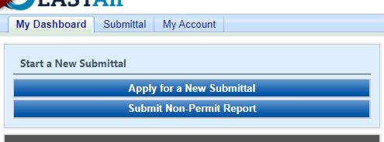
Figure 1 Dashboard buttons to create a new submittal

Alternatively, you can go to Submittal and select “Start a New Submittal”

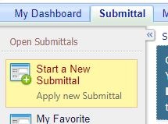
Figure 2 Submittal menu

After selecting “Start a New Submittal”, you will need to change the Submittal Category to “Report” or “All” in the Category dropdown list at the top of the page.

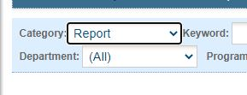
Figure 3 Select submittal category

No matter which method you use to get to this point, you will see icons for the two types of reports that are available in the Iowa EASY Air system. Those are the Start of Construction and Start of Operation Notices.

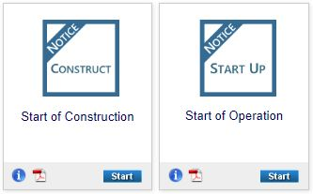
Figure 4 Notice Icons

To submit one of these reports, click the start button for the one you wish to submit. After that is completed, you will get a list of the reports that are required for all of the facilities with which your account is associated.

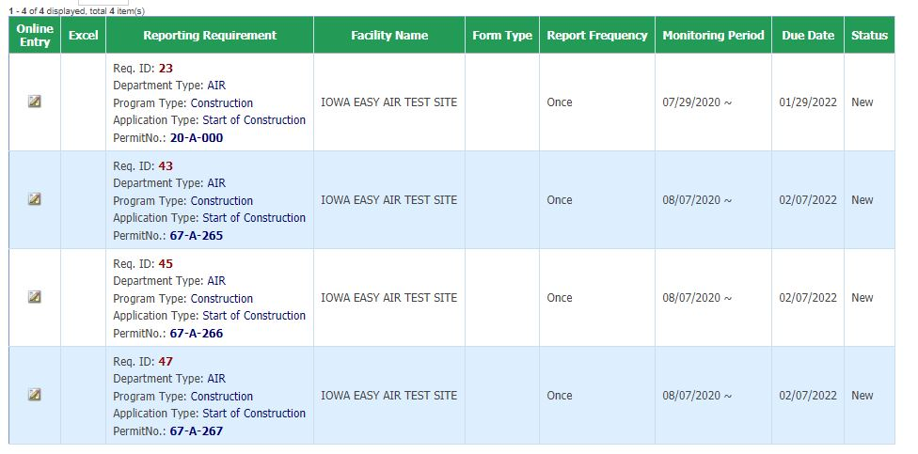
Figure 5 List of permits with pending notices

If this list is lengthy you can search the list using the search boxes at the top of the screen

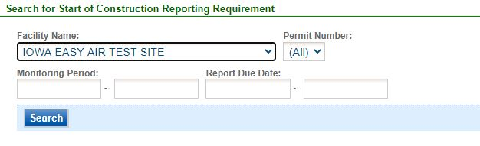
Figure 6 Searching permit list
The Facility Name box will be a dropdown of those facilities with which your account is associated. They monitoring period start date should be the date the permit was issued. The report due date would be 18 months after the date the permit was issued for start of construction notices and 36 months after the date the permit was issued for start of operation notices.

Once you have found the permit that you would like to submit a notice for, click the icon in the “online entry” column at the left-hand side of the table associated with that permit. On the following screen just click continue to the online entry form.

Form Data Entry
When you get to the online entry form, the top two sections of the form should be pre-populated with all the information about the permit you selected.

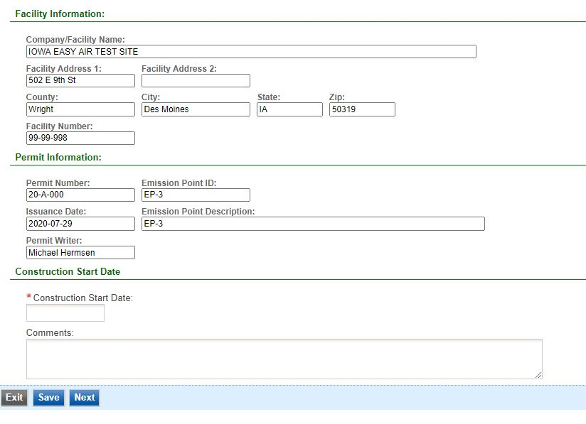
Figure 7 Data Entry Form

All you will need to do is complete the third section of this form. To do so, enter the appropriate date for start of construction or start of operation depending on which form you are completing. If the permit was a modification and no physical change or change in the method of operation was made to the equipment, enter the date the permit was issued for both start of construction and start of operation.

There is a comments section to allow you to provide additional information if necessary but it is not required. After you have completed your entry of information onto the form, click Next.

Once you click next on the notice form, you will get a validation screen to verify that all necessary information was provided.
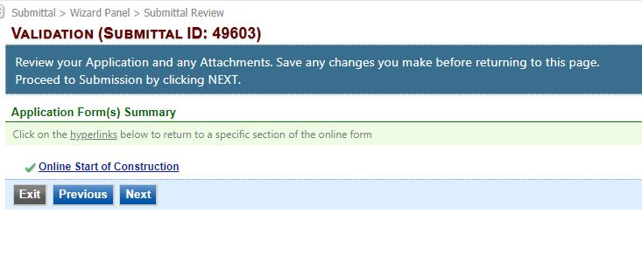
Figure 8 Data Validation

If there are no errors identified on the validation screen, proceed to the next step by clicking “next”. This will take you to the certification screen.

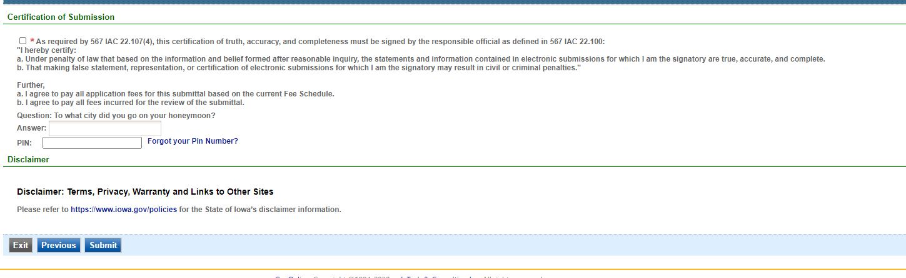
Figure 9 Submittal Certification

This certification is similar to that which is completed when submitting an application. After completing the necessary information on the certification screen, click the submit button to complete the processes.

You have completed the process to a start of construction or start of operation notice. If you need to submit more than one you will need to repeat this process for each one.

It should be noted that this process is only available for permits that were issued after November 7, 2019.

If you have questions, please call the Iowa EASY Air Helpdesk
at (515) 725-9569 or (515) 725-9523.
Or, send an email to easyair@dnr.iowa.gov

